* 1. **Be organized when creating your content**

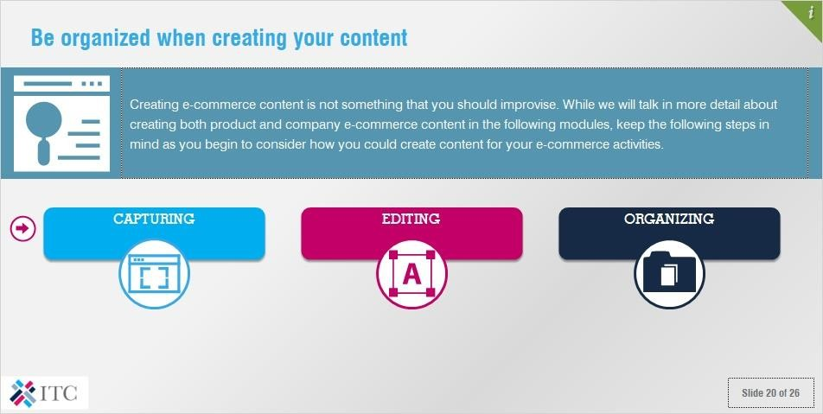

Creating e-commerce content is not something that you should improvise. While we will talk in more detail about creating both product and company e-commerce content in the following modules, keep the following steps in mind as you begin to consider how you could create content for your e-commerce activities.

# Capturing

Content creation starts by capturing all of the information necessary to effectively showcase both your company and your product. In doing this, keep in mind that the best source of information about a product is its producer. If that’s you, great! If not, we highly recommend contacting your suppliers to learn more about their production process.

# Editing

Editing involves selecting and preparing written, visual or audible media to convey the information that you have captured in an appealing way. Keep in mind that different stakeholders prefer different media, as well as different tones for your content.

# Organizing

It is paramount that you organize your e-commerce content once you have edited it. If you do not keep your content organized, you will quickly lose track of it, particularly after some time has passed. Wherever you store your files and other electronic documents, use a naming standard that will allow you to quickly find them and keep track of different versions (i.e. “raw” vs. “edited”).

# Making effective use of e-commerce content

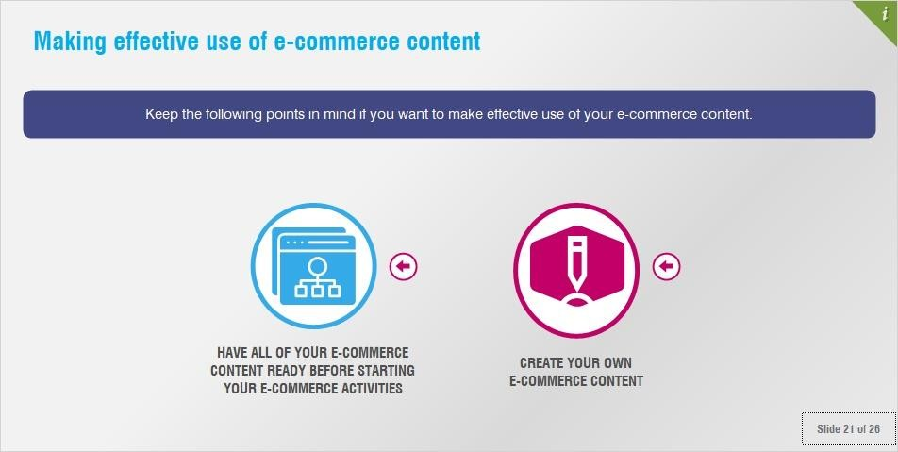

Keep the following points in mind if you want to make effective use of your e-commerce content.

# Have all of your e-commerce content ready before starting your e-commerce activities

Since 80% of the e-commerce content that you create will be relevant to all of the stakeholders in the e- commerce value chain, making sure that everything is ready to go before you even begin will save you a lot of time and additional work.

If you do not have your e-commerce content ready before you begin, you might find yourself unable to use important e-commerce services, such as those of payment or logistics providers, customs authorities, or VMPs. What’s more, if your prospective buyers find your information lacking, they are likely to buy from your competitors, rather than investing additional time and money to obtain the necessary content from you.

This means that creating quality e-commerce content is an economically advantageous proposition. Once you have created it, it is a matter of a few clicks for you to upload and publish it to hundreds of online channels. Using data feed management will allow you to quickly and easily update your product information across hundreds of marketplaces and price comparison engines.

# Create your own e-commerce content

Make the effort required to create your own e-commerce content. While this may be a little time consuming, it is generally not very expensive and will save you a lot of trouble down the road. By creating your own e- commerce content, nobody can stop you from using it, or accuse you of plagiarism. In addition, you will avoid any miscommunication or misuse of your content by third parties.

We recommend including a copyright notice on your website when it becomes available to the public. Doing so will not cost you anything any may help to deter plagiarism or provide proof if you ever decide to sue somebody for copying the content that you have created.

# Ownership and plagiarism

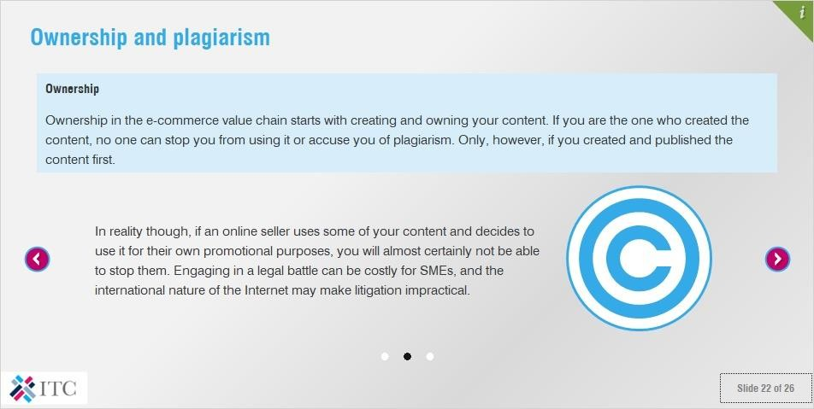

**Ownership**

Ownership in the e-commerce value chain starts with creating and owning your content. If you are the one who created the content, no one can stop you from using it or accuse you of plagiarism. Only, however, if you created and published the content first.

If another online seller takes a photo of your product or design and publishes it online claiming it as their own, you will not be able to contest their claim unless you can prove that you were the first to create and publish it (e.g. through proof of domain name registration or screenshots from an Internet archive), or through other IP protection measures such as registering a trademark, etc. Including a copyright notice on your website can also help.

In reality though, if an online seller uses some of your content and decides to use it for their own promotional purposes, you will almost certainly not be able to stop them. Engaging in a legal battle can be costly for SMEs, and the international nature of the Internet may make litigation impractical.

This is why publishing content early and often is key. Google and other search engines have algorithms to recognize plagiarism, based on a piece of content’s date of publication. This means that, if you are the first to publish a given sentence, image or video, search engines will recognize that it is original, and redirect more traffic to it. As such, any competitors who attempt to plagiarize you will have a hard time getting traction; search engines are designed to send visitors to the most authentic and earliest source of a given piece of content.

# Being responsible for what you publish

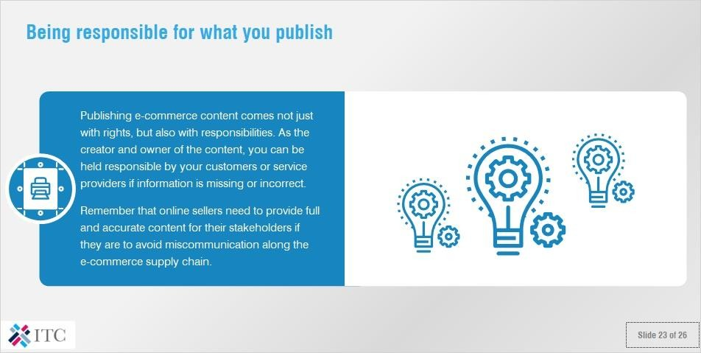

Publishing e-commerce content comes not just with rights, but also with responsibilities. As the creator and owner of the content, you can be held responsible by your customers or service providers if information is missing or incorrect.

Remember that online sellers need to provide full and accurate content for their stakeholders if they are to avoid miscommunication along the e-commerce supply chain.

# Activity – Creating your own e-commerce content

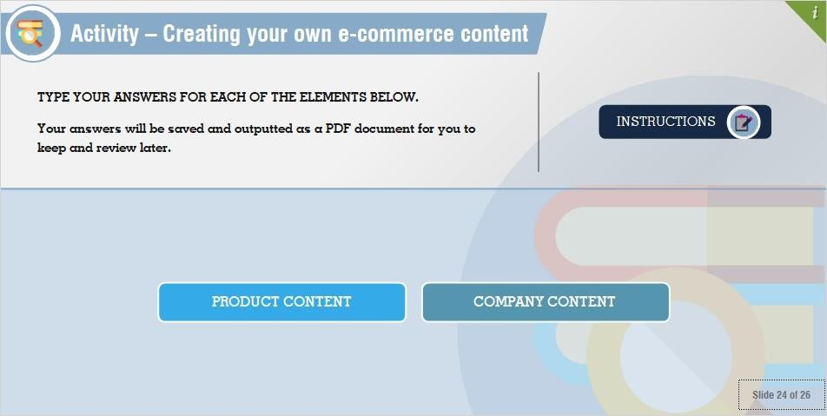

**This exercise is not available in the PDF version of this lecture.**

* 1. **Key Points**

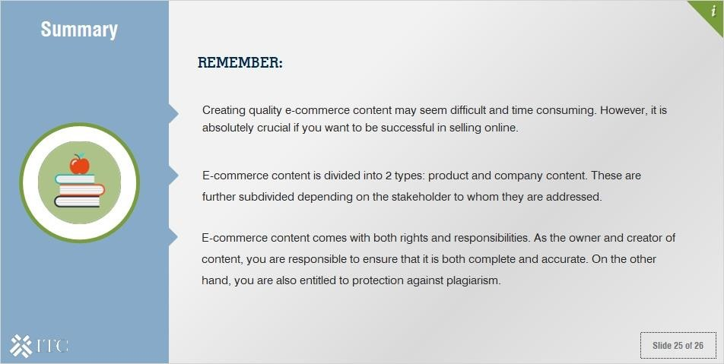

Remember:

* Creating quality e-commerce content may seem difficult and time consuming. However, it is absolutely crucial if you want to be successful in selling online.
* E-commerce content is divided into 2 types: product and company content. These are further subdivided depending on the stakeholder to whom they are addressed.
* E-commerce content comes with both rights and responsibilities. As the owner and creator of content, you are responsible to ensure that it is both complete and accurate. On the other hand, you are also entitled to protection against plagiarism.